# **Blender Car Damage Masking Documentation**

## **Table of Contents**

1. Introduction
2. Prerequisites
3. Importing the Car Model
4. Importing Assets and Applying Them to the Car Model
5. Running the Python Script
6. Changing the Mode Switcher Node
7. Creating Damages
8. Applying Dirt Texture
9. Applying the HDRI Dome
10. Generation
11. Unresolved Challenges
12. Specific Problems
13. Resources

## **1. *Introduction***

This documentation will walk you through the process of adding realistic damage, like dents and scratches, to a car model using Blender.

In this project, we'll use a Blender script to create these damage masks and then render the results, saving them neatly into a folder on your PC.

## **2. *Prerequisites***

* **Blender Installed**: Blender version 4.1 or above.
* **Car Model File**: Any car models.You can import it from online
* **Render Engine**: This project uses Cycles as the render engine.
* **Assets**: Assets can browsed through asset browser

## **3. *Importing the Car Model***

You have two options to import your car model:

### **Option 1: Import from File**

1. Open Blender.
2. Go to File > Import and select the format of your car model.
3. Navigate to the car model file and import it into Blender.

### **Option 2: Using BlenderKit Addon**

1. Download the BlenderKit addon: [BlenderKit](https://www.blenderkit.com/accounts/register/?next=/get-blenderkit/207fca9d-e14e-41f6-8ae8-b1b045a752bc/). A zip file is also included in the folder provided.
2. Open Blender.
3. Go to Edit > Preferences (or press Ctrl + ,) and navigate to the Add-ons section.
4. Enable the BlenderKit addon.
5. Use the search option in the BlenderKit interface to find and import the car model you want by typing "Car" in the search bar.
6. Click on the car model to import it into your scene.

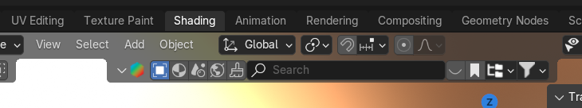

## **4. *Importing Assets and Applying Them to the Car Model***

1. Open the Asset Browser in Blender.

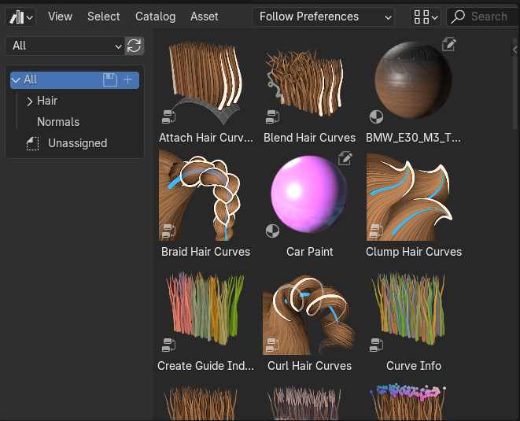

1. Drag and drop the desired asset onto the car model where you want the damage texture to be applied.

## **5. *Running the Python Script***

1. After applying the assets, switch to the Scripting workspace.
2. Python script in the following link:[Python Script](https://drive.google.com/file/d/1UUI9N4dCVJvSPziX1aSbcp9XTd5xiCOh/view?usp=drive_link).

## **6. *Changing the Mode Switcher Node***

1. After running the Python script, go to the Shading tab.

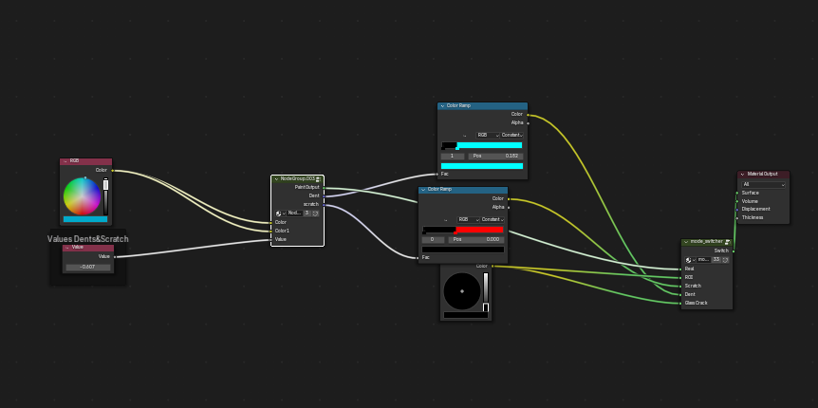

1. Open the Shader Editor.
2. Locate the Mode Switcher node in your shader editor.
3. Add a new Mode Switcher node if it doesn’t appear automatically or change the Mode Switcher to the latest “mode switcher”.

## **7. *Creating Damages***

### **Dents**

* Adjust the Voronoi Texture and Mapping node scales to create suitable dents on your car model.

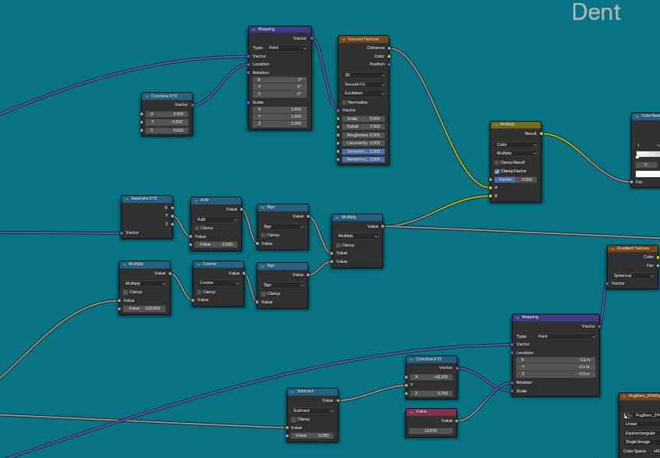

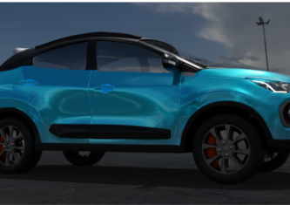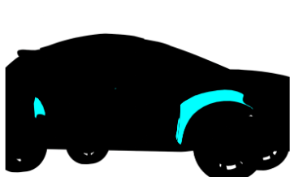

### **Scratches**

* Modify the values and Mapping node scales to generate appropriate scratches.

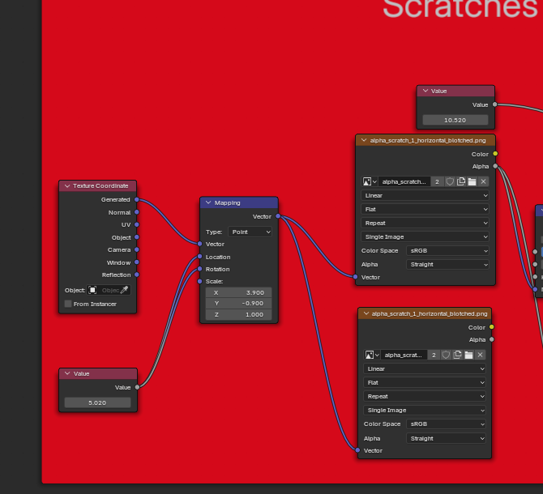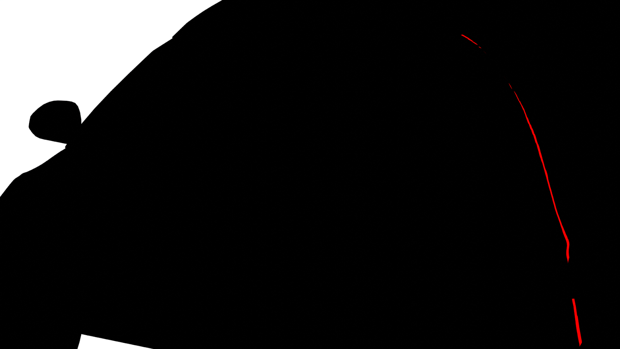

### **Glass Cracks**

* Add and configure the nodes to simulate realistic glass cracks.

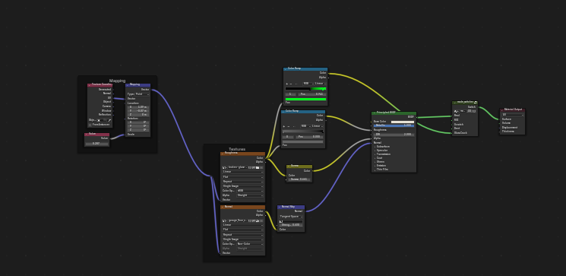

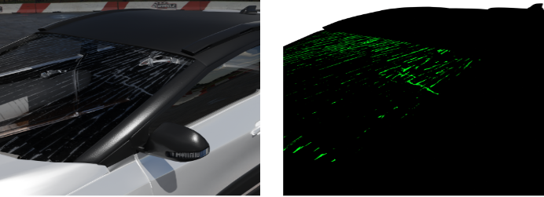

## **8. *Applying dirt texture***

To add dirt texture, follow this tutorial [Simple Dirt & Dust in Blender - NOT in Substance](https://www.youtube.com/watch?v=7F6jzEybPKU)

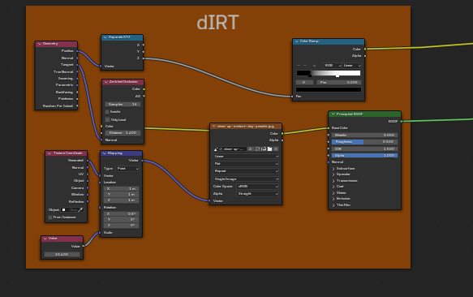

## **9. *Applying the HDRI Dome***

Instead of importing an HDRI image directly to the world texture,we are using dome hdri.Perks of using dome hdri is it helps in making the car stay on ground unlike world hdri. Follow this tutorial to create the HDRI dome: [HDRI Dome Tutorial](https://www.youtube.com/watch?v=aJy_KZSyDlY&list=PPSV) (Relevant Timeline: 6:03 - 17:38).

* You can switch HDRIs by clicking the file icon in the node setup and selecting a different HDRI.

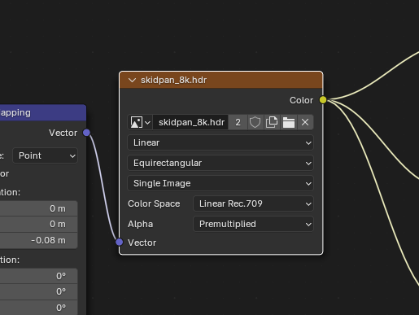

## **10. *Generation***

Once you’ve configured everything:

1. Select the number of samples you want to generate.
2. Click on Generate to start rendering your car model.

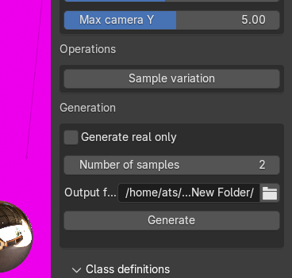

## **11. *Unresolved Challenges***

While this guide provides a solid foundation, some challenges remain:

* Needs better procedural Dents and scratch texture
* Needs proper lightning to match the background of the car
* Dent randomizing on one side
* Needs better realism light reflection on car material

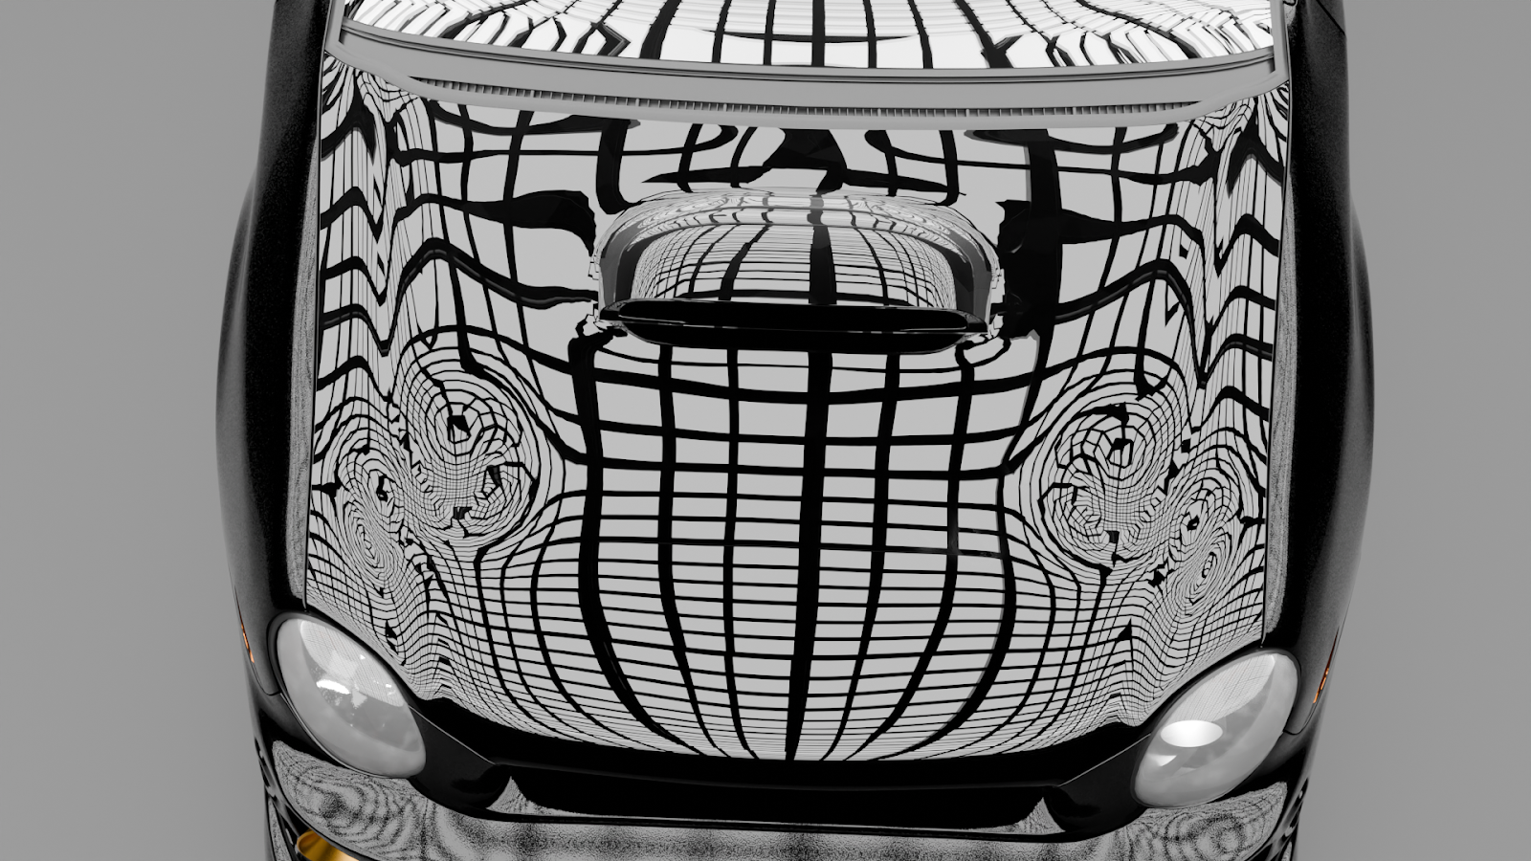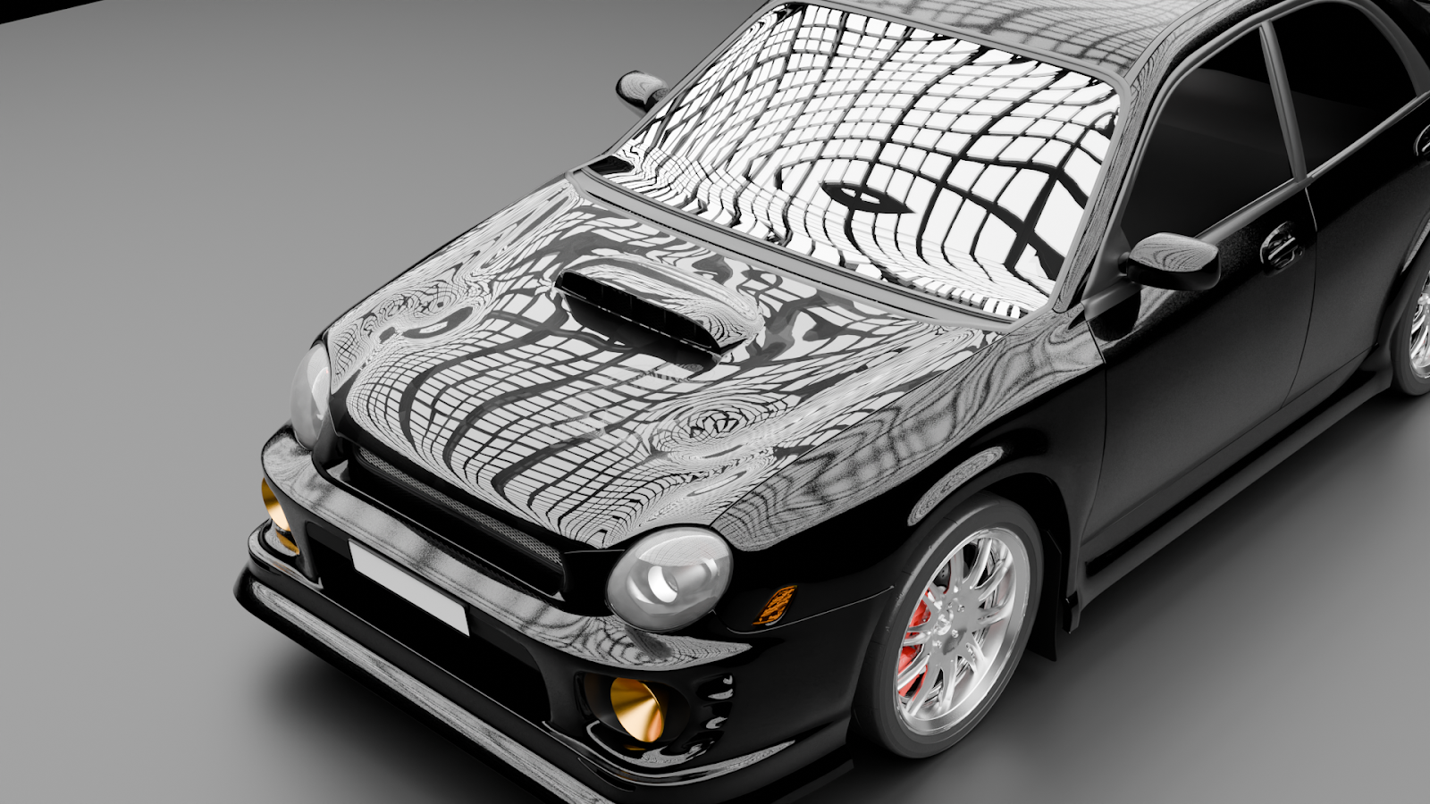

* Dents need to be implemented manually.

## **12. Specific Problems that needs to be Addressed**

* Needs proper detailing in the hdri environment.
* Needs better understanding of geometry nodes for better detailed dents.
* No proper placement of dents.

## **13. Resources**

* Texture resource: [Texture resource](https://drive.google.com/drive/folders/1pdVvE4Iy5UDwf-opVEpgLbMOX85w-kB3?usp=drive_link)
* Car models **:**
  + 1. <https://drive.google.com/drive/folders/1pdVvE4Iy5UDwf-opVEpgLbMOX85w-kB3?usp=drive_link>
    2. <https://sketchfab.com/categories/cars-vehicles>
    3. <https://free3d.com/3d-models/vehicles>
    4. <https://www.turbosquid.com/3d-model/free/car>